Bangladesh University of Engineering and Technology

Department of Computer Science and Engineering

**CSE 316**

Microprocessors, Microcontrollers, and Embedded Systems Sessional

**Experiment 1**

**AVR Microcontroller: Use of Polling for Digital IO.**

**GOAL:**

Use ATmega32 microcontroller to implement a 4 bit up-down counter.

**EXPERIMENTAL TOOLS AND MATERIALS:** ATmega32, USBASP programmer, Trainer Board, Wires, Avr Studio, Extreme Burner, two push buttons, two 10kΩ resistors (1kΩ resistors should work fine too)

**EXPLANATION OF PRINCIPLES:**

Push buttons and LEDs will be used to do input-output. Polling will be used to detect the button press.

**PROCEDURE:**

1. Connect two active high push buttons to two pins of ATmega32 (according to instructions given by the teachers during the lab).
2. Connect 4 LEDs to PORT A (lower 4 bits)
3. Write a C program to implement a counter. The 4 LEDs will be used to show the count and the  
   the counting function will be specified by the teachers. Pressing one button will count up while pressing the other button will count down. Use a polling approach to detect button presses.

**MISCELLANEOUS:**

1. Connect the buttons according to the following diagram:  
   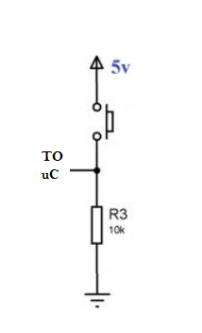  
   For more details refer to:   
   <https://electrosome.com/push-button-switch-atmega32-microcontroller-atmel-studio/>
2. Some pins of PORTC can not be used for I/O directly. First the JTAG has to be turned off.   
   One way is to uncheck the JTAG box while writing the fuse bits, the second is to write a 1 to the JTD bit twice consecutively. MCUCSR = (1<<JTD);   
   For more details refer to:   
   http://www.avrfreaks.net/forum/jtag-enablingdisabling-atmega32-and-fuse-settings-solved
3. You do not need to bother about FUSE bits. By default it is set to: E199  
   If the JTAG Interface is disabled it will be set to: E1D9. You can calculate fuse bit from this online tool: <http://www.engbedded.com/fusecalc/>